Practical-11: Programs Using Pre-processor Directives.
1) | Illustrate use of #define preprocessor.
 | Program :-
#include<stdio.h>
#define PI 3.14
#define PRINT(a)(printf(a))
#define PRINTI(val)(printf("%f\n",val))

void main(){
float a=PI;
printf("%f\n",a);
printf("Value of PI: %f\n",PI);
PRINT("John\n");
PRINTI(10.25);

#ifdef PRINT
printf("PRINT MACRO IS DEFINED\n");
#endif

char str[]="VIDIT";
PRINT(str);
}

 | Output :-
 | 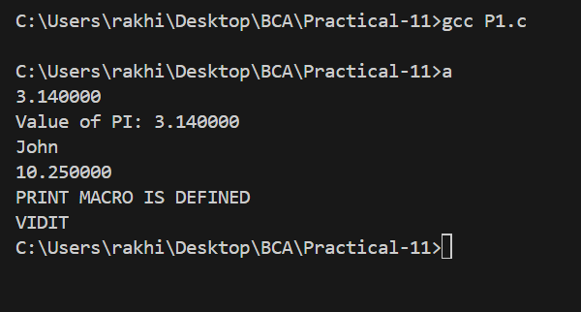

2) Get current time using __TIME__.
Program:-
#include<stdio.h>
void main(){
printf("Current time: %s\n",__TIME__);
printf("Current time: %s",__DATE__);
}

Output:-

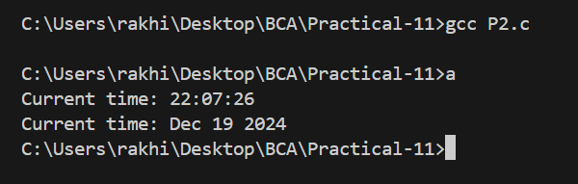

3) Deƒne a function like Macro that should use printf Deƒne Macro PRINT to print given integer argument.
Program:-
#define PRINT(val)(printf("%d",val));
#include<stdio.h>

void main(){
PRINT(10);
}

Output:-
